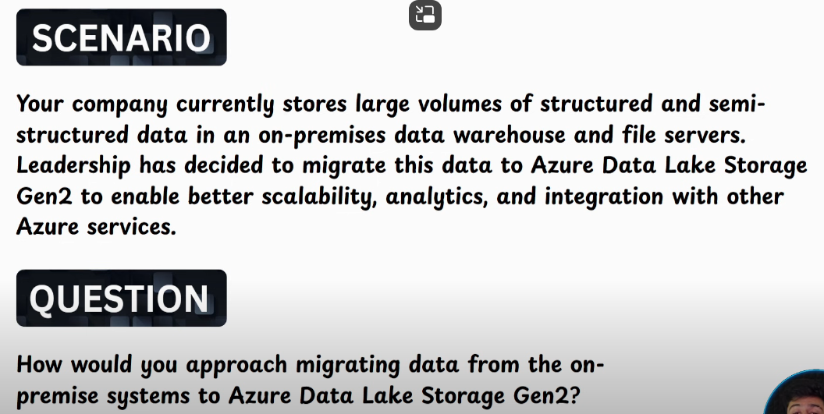  
Use Self Hosted IR  
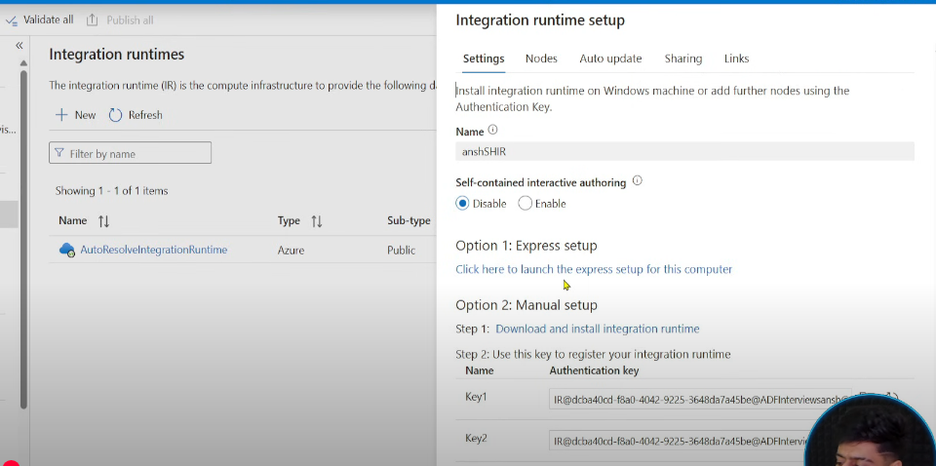  
We need to install a package in our Local Machine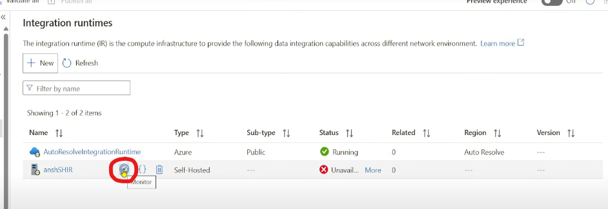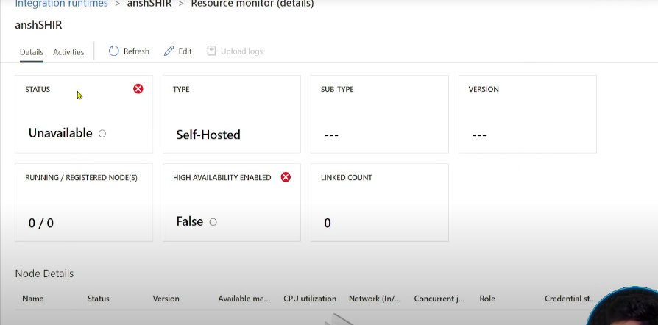  
So start installing using Manual setup (advisable), post installing provide the key.  
In real world, we create VMs as our IR(instead of downloading in local machine, download the IR in VM), in case of throttling(CPU utilisation is 80-90%) scale up VM. Easy to scaleup VM instead of local.  
Post that create a LS for the datastore using SHIR.

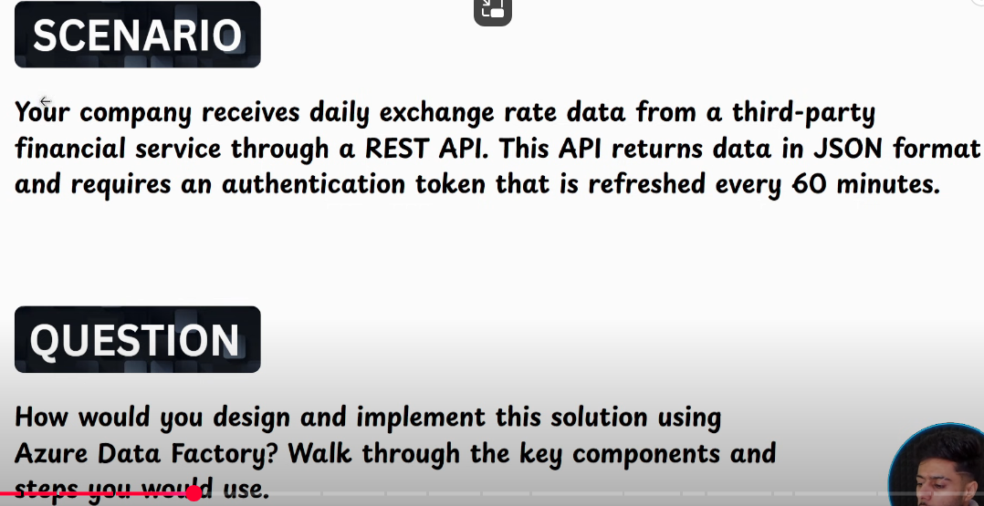  
Sample API from Postman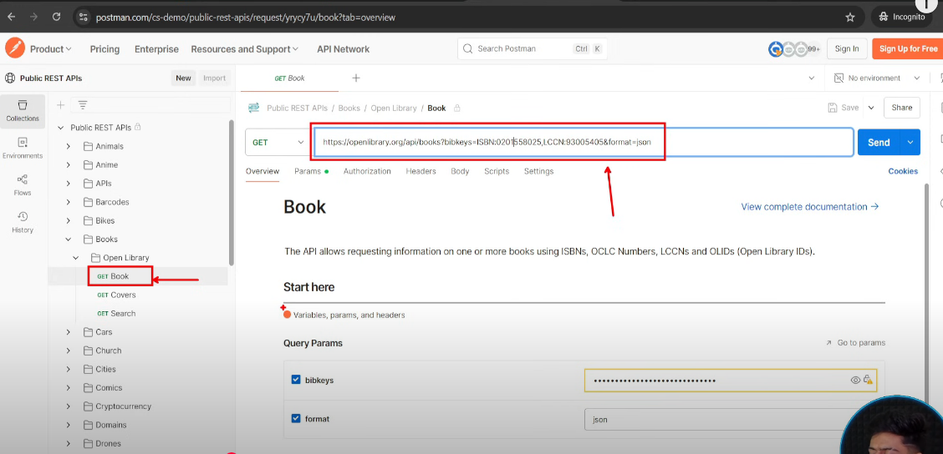  
Query parameters: used for authentication of API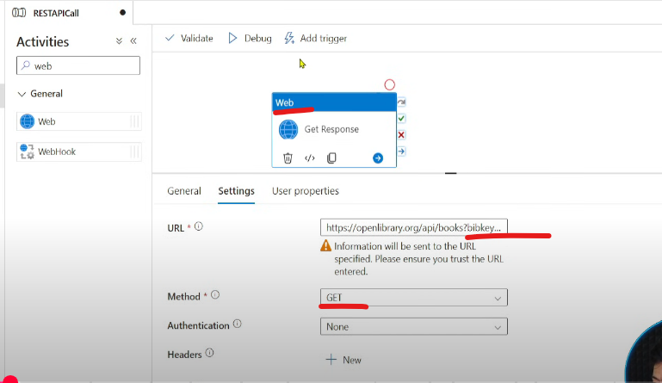  
Debug to see output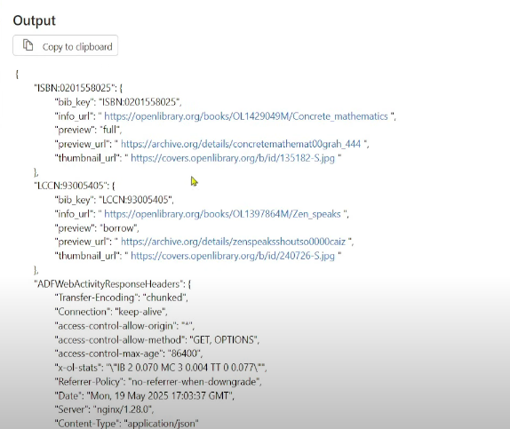  
Use a Copy activity to store the response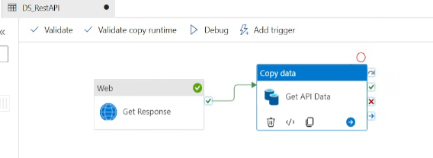  
Source 🡪 REST dataset with REST LS  
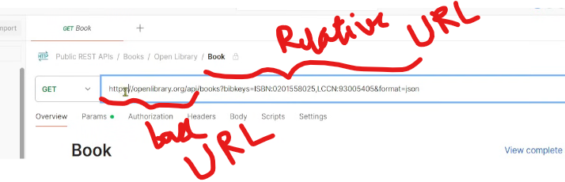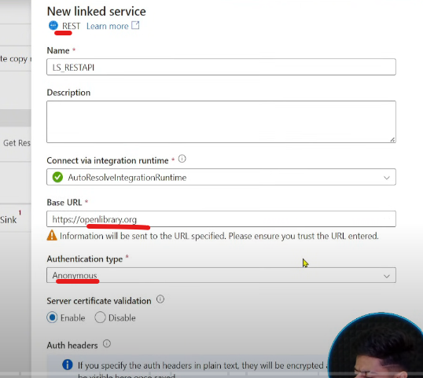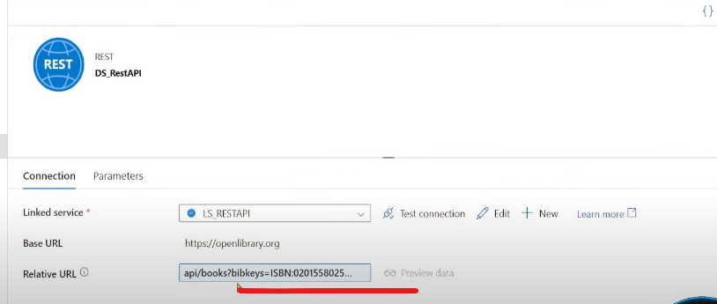  
Sink 🡪 ADLS in JSON format  
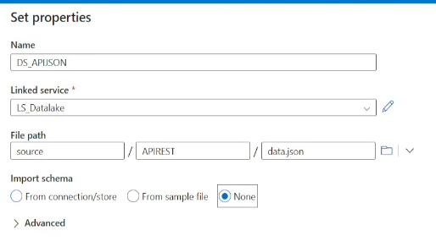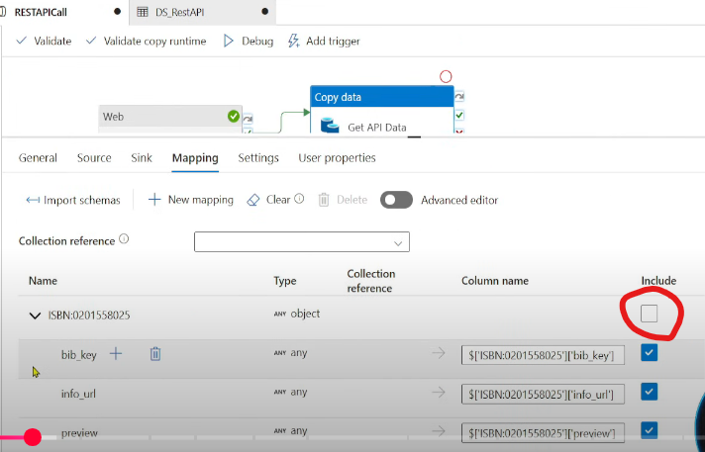

Include the parent object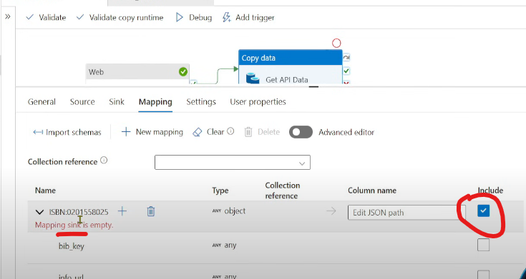  
Now click on Import Schemas again 🡪 Now debug the pipeline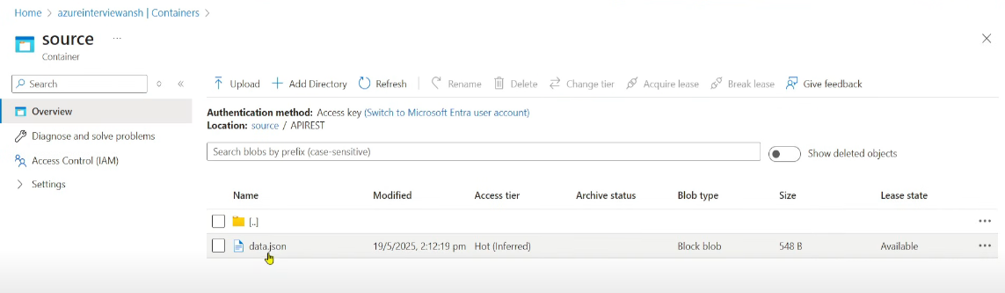  
  
Additional: Now let’s consider if the output of Web activity is in csv format(not in json format) 🡪 Always use HTTP connection instead of REST in case of Delimited text  
Because HTTP has an option of choosing Format (REST doesnot have)

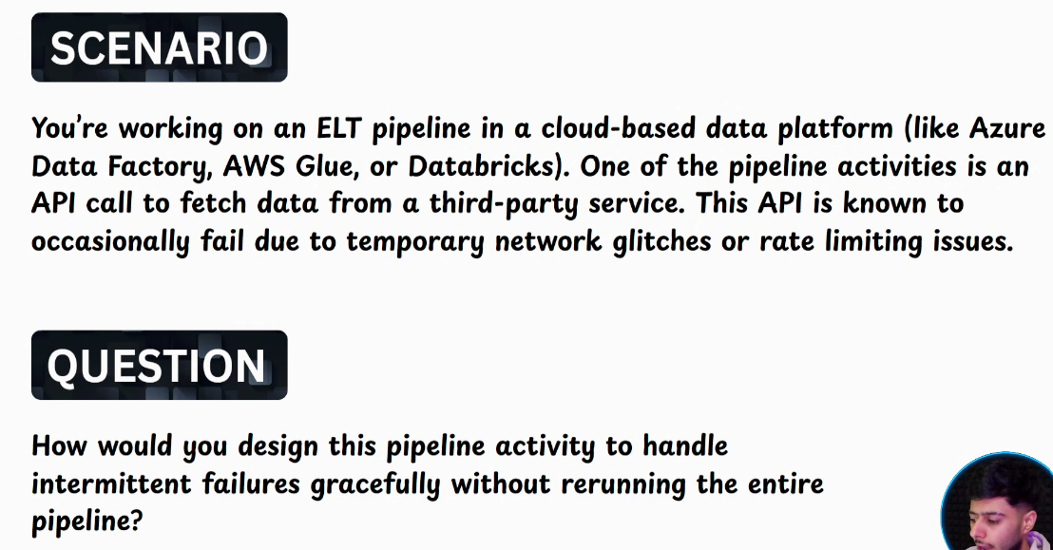  
Make pipeline robust enough to retry from the failed activity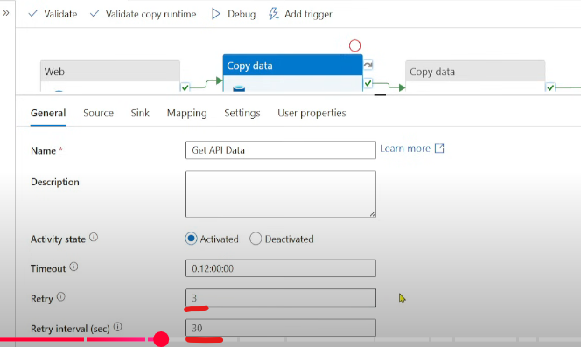

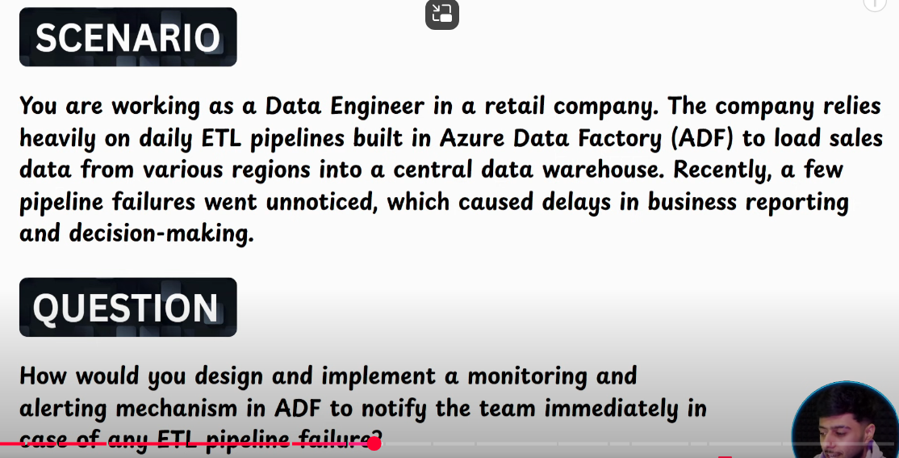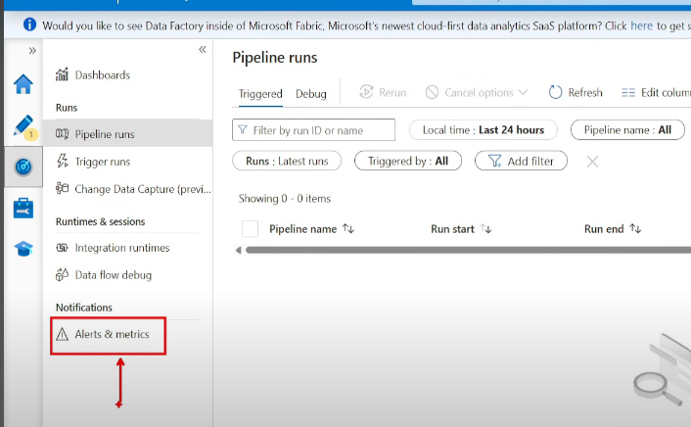  
Setup Alerts & metrics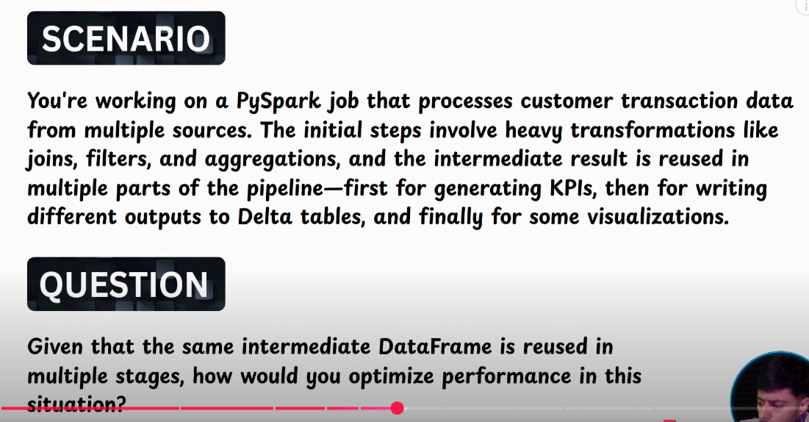  
Whenever we create a dataframe, executor doesn’t hold the dataframe in the execution memory for long time, it will eliminate dataframe immediately if it is assigned a different task or need to create a new df from an existing df.  
Use cache() or persist()  
Execution memory will be cleaned everytime there is a new job, so it will follow the DAG and start from the first step, so its better to store in storage memory.  
Make sure to use unpersist() post completion.  
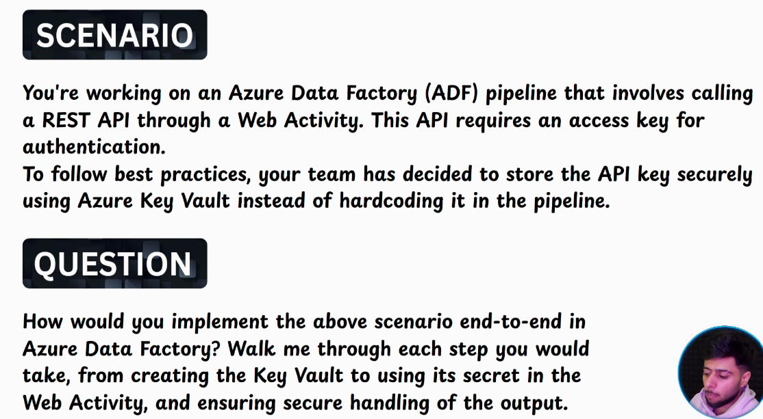  
Create AKV 🡪 Grant KV Administrator role🡪 create secret 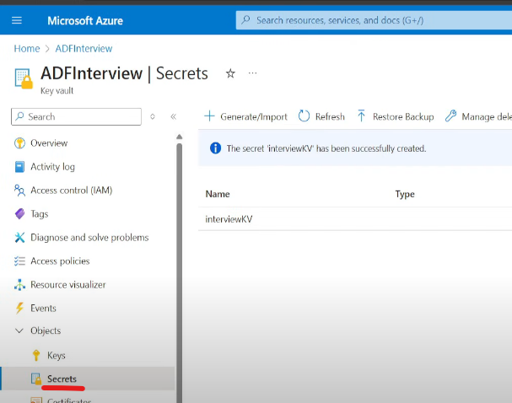  
I want to fetch this info using Web activity 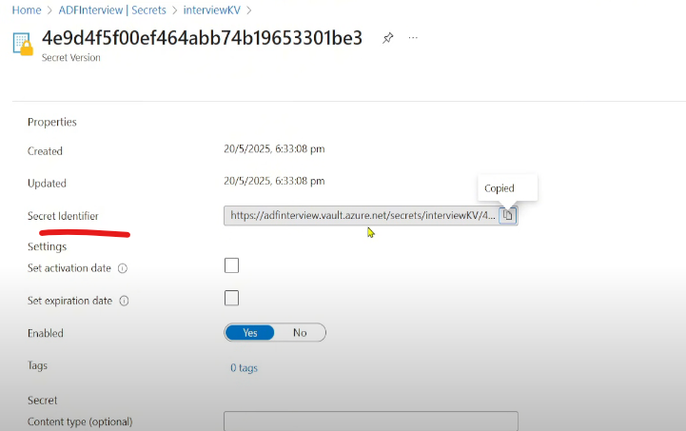  
Copy the secret identifier  
Grant ADF access to AKV (Go to AKV🡪 IAM 🡪 KV Administrator role🡪 Managed Identity) 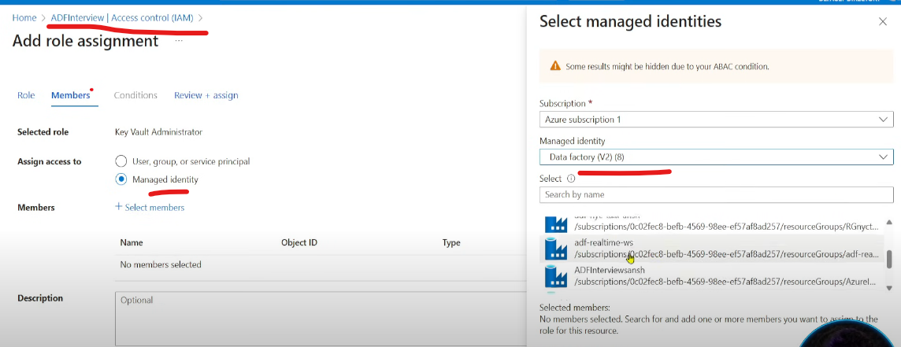  
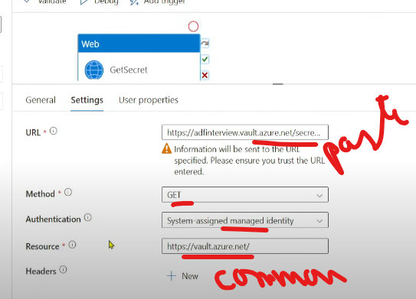 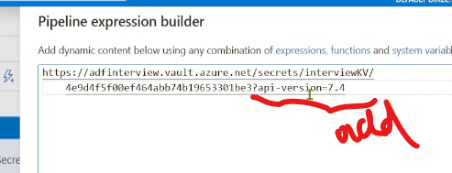  
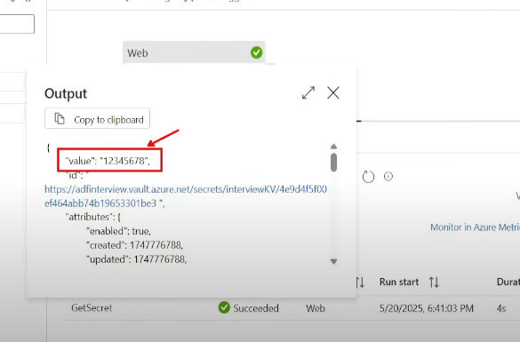  
We can see the value, ideally we should not 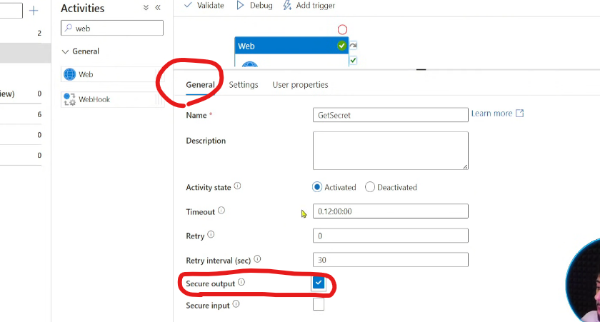  
Enable secure output  
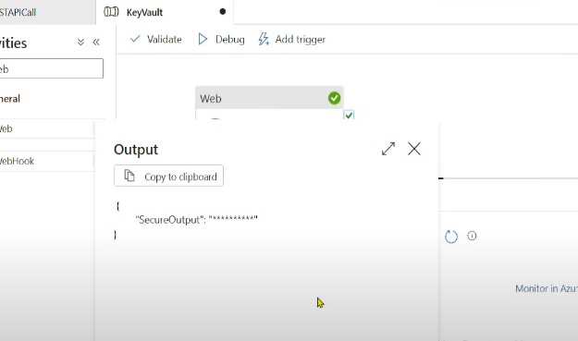 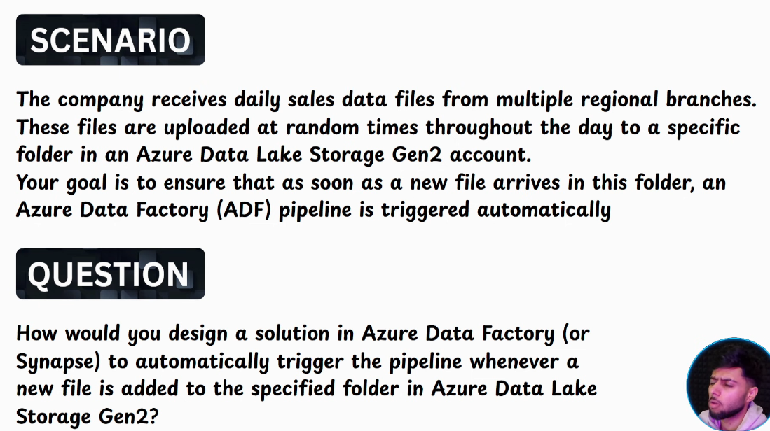  
  
M1 : Use Storage Events Trigger  
M2 : Use Validation activity 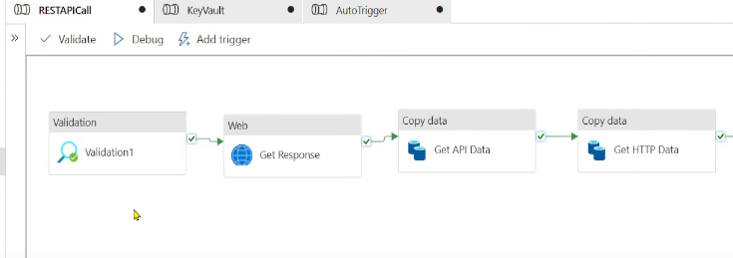  
Validation activity will be continuously searching for the file and then run the subsequent steps  
  
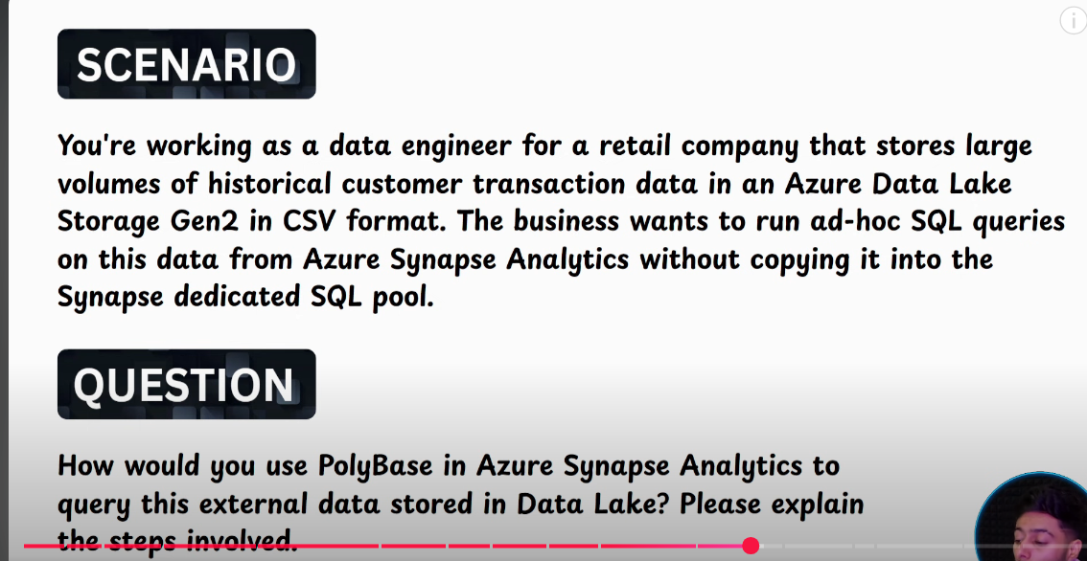  
In serverless SQL pool, we use Polybase  
Step 1: Create Master key for database  
Step 2: Create credential  
Step 3: Create External Data Source  
Step 4: Create External File Format  
Step 5: Create External Table

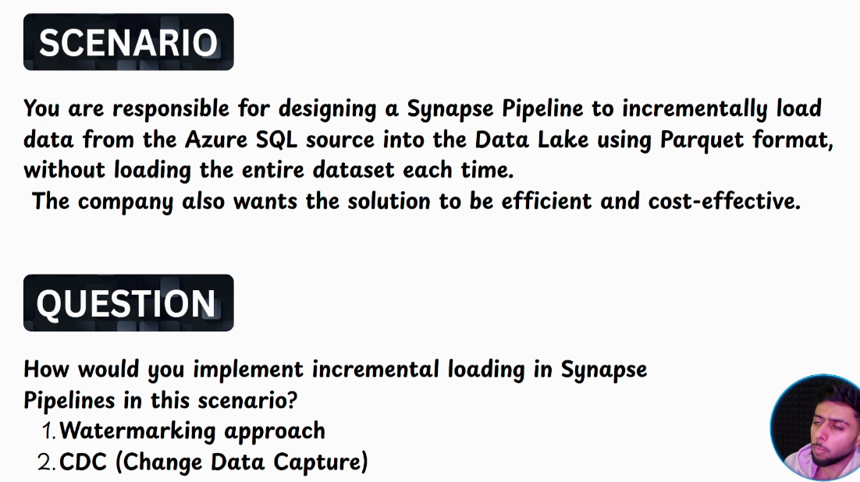  
CDC as of now works when we have SQL db as a source  
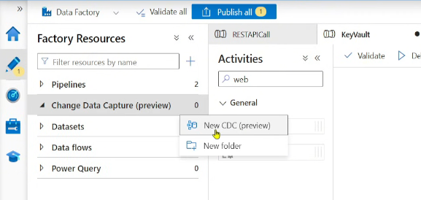 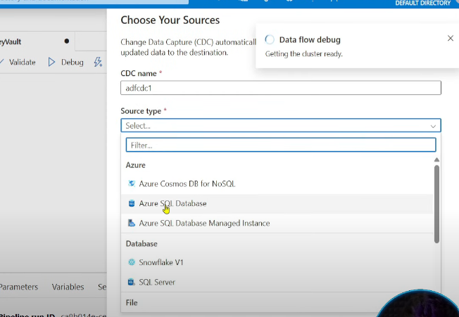 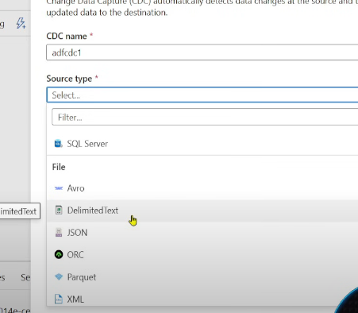  
Enable CDC in the DB   
Enable CDC in the Table  
Connect the Table

**Watermarking**  
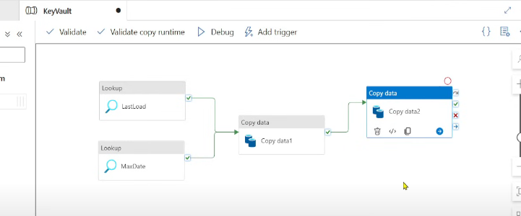  
Instead of Stored Procedure, store the data in file

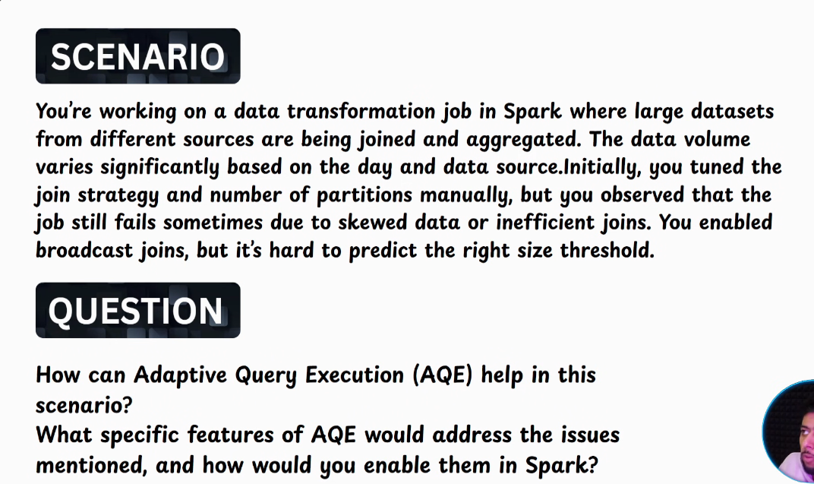  
AQE : calculates query statistics during runtime based on that it addresses the manual threshold for broadcast join  
(Before AQE, LP🡪PP) With AQE, LP🡪PP🡪Query statistics  
Addresses skewness, Dynamically coalesces the partitions

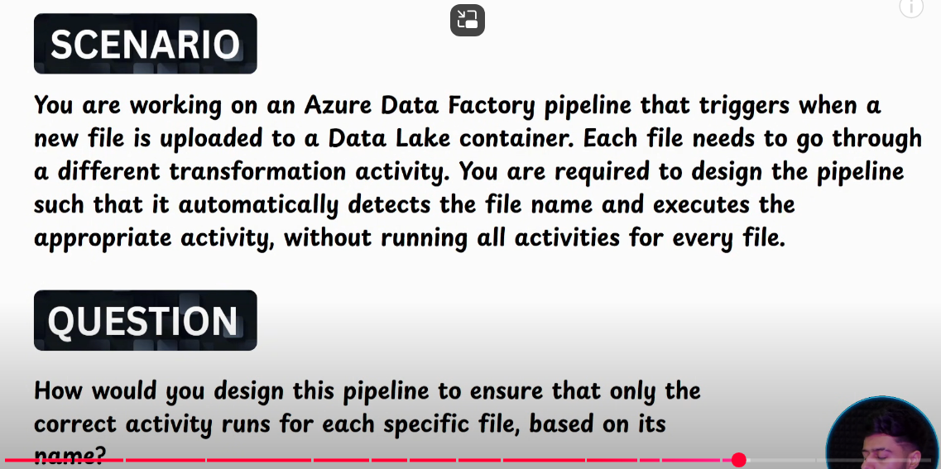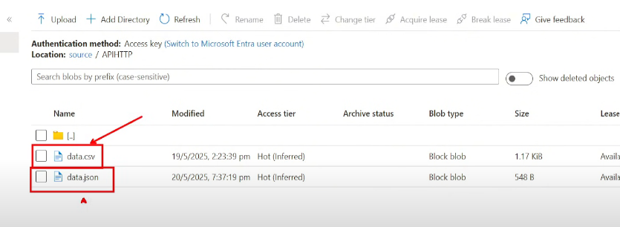  
Want to perform different sets of activities for each of these files  
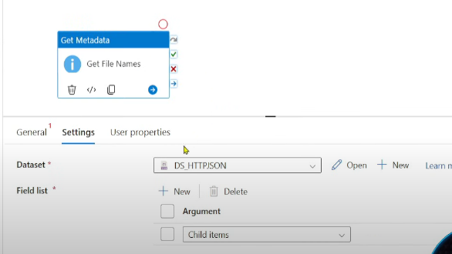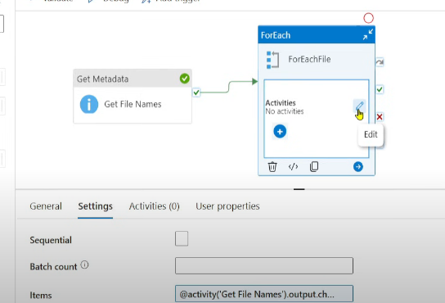 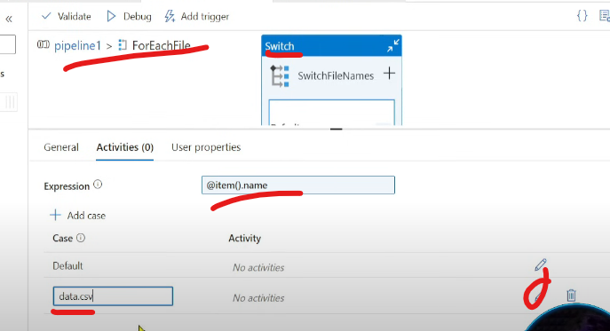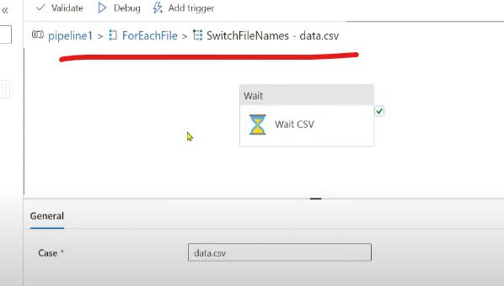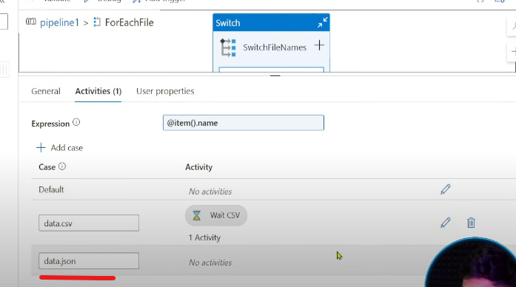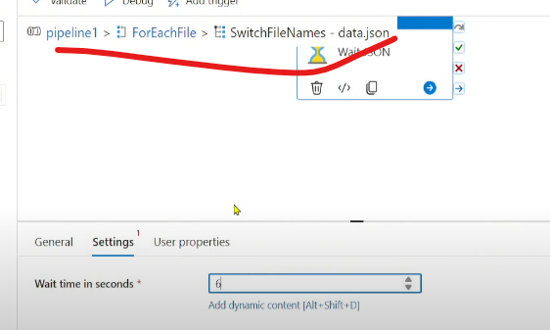  
We cant use . in case conditions  
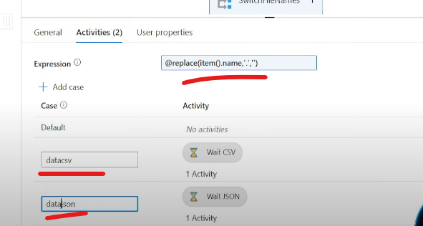  
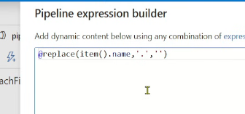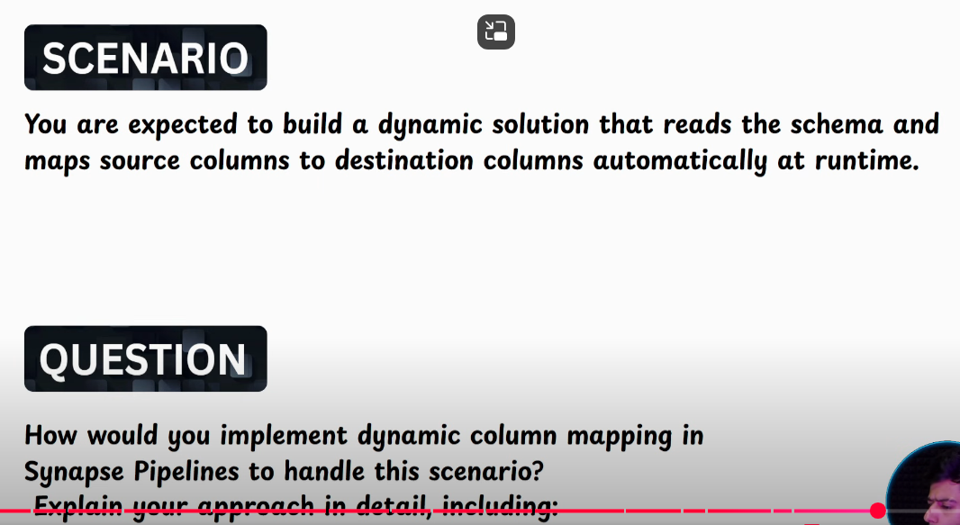  
Copy the translator code  
  
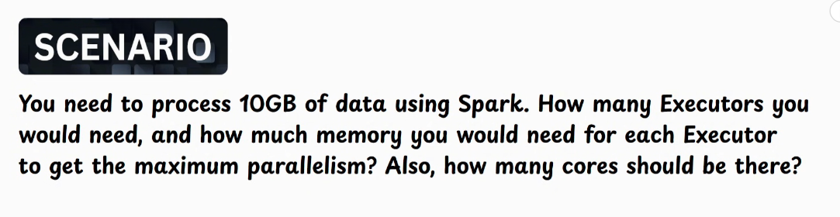  
S1: 10GB 🡪 80 partitions  
S2: Leverage max parallelism🡪 80 partitions 🡪 80 cores  
S3: No of cores🡪 5 per executor 🡪 80/5 🡪 16 executor  
S4: Memory for each Executor 🡪 In each executor 5 cores, each core will process 1 partition sized 128MB i.e. 128*5 = 640MB  
640MB is not the total memory, 640MB is required just to execute the task, we get 30% memory to execute the task. 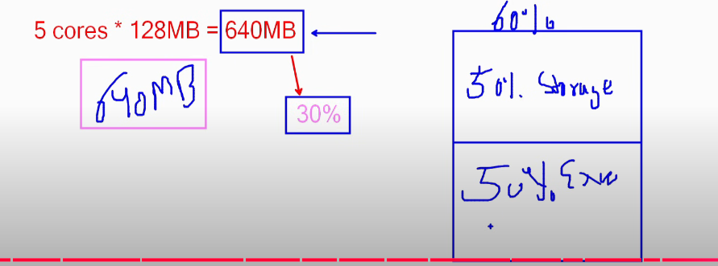  
Spark pool memory is 60%, 40% off heap.  
Out of 60%, 50% is storage memory/caching & 50% is execution memory.  
So 640MB is equivalent to 50% execution memory.  
So we multiply 640 with 3.5-4 to get the total executor memory   
Total Executor memory = 2.6 GB